### 

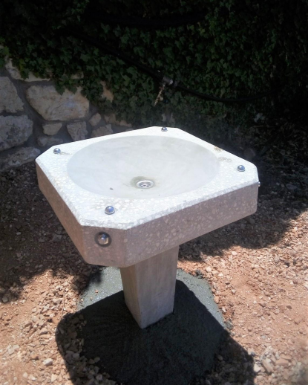

### https://lh3.googleusercontent.com/jAXZjm9s3cCECu1UVVvQeFtL-YoHalsFkXxkXRRmbs0N0hI_zi9KekD4xgxLQrNZVrHVWafKpRwlb1r_d8-xFDw8ZsYubCo0grAm9LOBfMKFVRoOgJFgOKQGX0libRwx1vm9Vl6R